**Project Documentation**

Store Manager

**1.Introduction**

* Project Title: Store manager
* Team ID:
* Team Leader:

-Sridevi A Mail id: sridevi008@gmail.com

* Team Members:

-Sridharshini G Mail id: gsridharshenni07@gmail.com

-Srilekha R Mail id: srilekharajkumar175@gmail.com

-Sujitha R Mail id: sujimaha1221@gmail.com

**2.Project Overview**

* Purpose:Inventory Management helps maintain healthy stock levels in a store and acquire them in time.
* Features:

**-Stock Updates:** Stock will automatically update on sale of products, and it can be updated on adding new stock.

**-Cart:** Products can be added to cart for a particular sale and quantity can be added to each product.

**-Checkout at Cart**: Upon checkout, cart is cleared, inventory is updated, and a sale record is made.

**-Adding New Products to Inventory:** New products can be added to the inventory by providing product name, image URL, price, stock, tags.

**-Alert View for Depleting Stock:** Depleting stocks are shown in red background, and alert count can be updated as per requirement.

**-Search Functionality for Products:** Products in inventory and product catalog can be searched.

**-Sale Records:** All sale records are stored with sale value, products and datetime.

**-Mode:** We can change between Dark mode and Light mode

**3. Architecture**

* **Frontend:** HTML, CSS, Javascript, React.js, Bootstrap
* **Database:** MongoDB

**4.Setup Instructions**

* **Prerequisites**:

-Visual Studio code(VS code)

-Node.js

-npm

-MongoDB

-Github Account

* **Installation Steps**

#Clone the repository git clone

#Install client dependencies

#Install server dependencies

**5.Running the Application**

* Create a new folder in desktop
* Download the zip folder of the project from github link
* Extract the files from the zipped folder and insert it into new folder created in the desktop
* Open the folder using VS code
* Open the terminal and run the following comments

**-cd storemanager-main**

**-npm install**

**-npm start**

**5.Folder Structure**

**storemanager-main**

│

├── **node_modules**

├── **public**

│ ├──cartImage.png

│ ├──favicon.ico

│ ├──index.html

│ ├──inventoryLogo.png

│ ├──logo192png

│ ├──logo512.png

│ ├──manifest.json

│ ├──robots.txt

├── **src**

│ ├── **components**

│ │ ├── **Cart**

│ │ │ ├──Cart.jsx

│ │ │ ├──Cartltem.jsx

│ │ ├── Inventory

│ │ │ ├──Inventory.jsx

│ │ │ ├──Product.jsx

│ │ ├── **Product**

│ │ │ ├── Product.jsx

│ │ │ ├──ProductCatalog.jsx

│ │ │ ├──ProductList.jsx

│ │ ├──**Sales**

│ │ │ ├──SaleRecord.jsx

│ │ │ ├──Sales.jsx

│ │ ├── AddProduct.jsx

│ │ └── NavBar.jsx

│ ├── **context**

│ │ ├── CartContext.js

│ │ ├── InventoryContext.js

│ │ ├── SalesContext.js

│ ├── **hooks**

│ │ └── useLocalStorage.js

│ ├── **pages**

│ │ └── NotFound.jsx

│ ├── App.css

│ ├── App.js

│ ├── App.test.js

│ ├── index.css

│ ├── index.js

│ ├── Layout.jsx

│ ├── logo.svg

│ ├── reportWebVitals.js

│ └── setupTests.js

├── .gitignore

├── package-lock.json

├── package.json

├── tailwind.config.js

└── README.md

**6.User Interface**

* Home
* Cart
* Inventory
* Sales
* Add Products
* Search Products

**7.Testing**

* Manual testing during milestones

**8.Screenshorts**

* Home 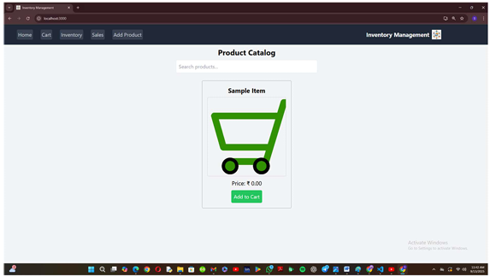
* Cart

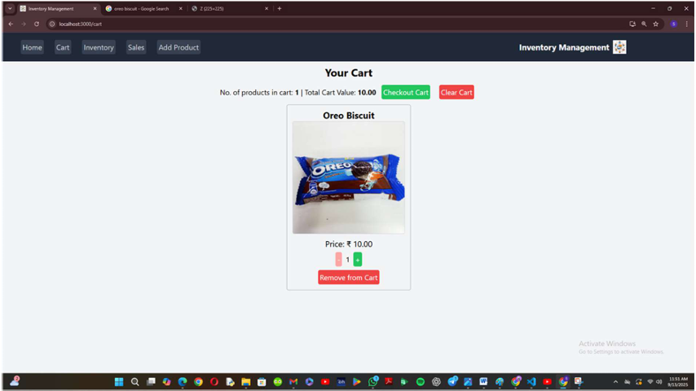

* Inventory

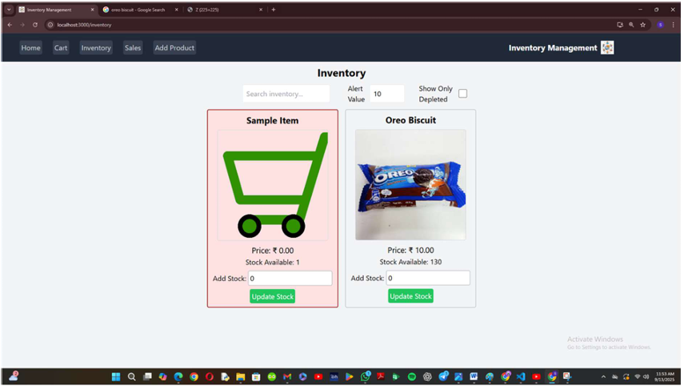

* Sales

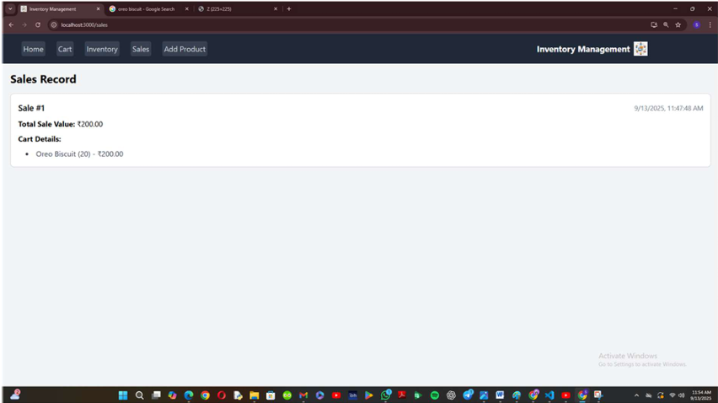

* Add Products

